System Requirements Statement (SRS) – BookMyTurf

Doc. Ref. : SRS_v0.4.doc
Version : 0.4
Status : Drafted
Created by : Kenji Tanaka
Date : 04-Dec-2012

1. Introduction 3
2. Functional Requirements 4
2.1 User Module 5
2.2 Admin Module 11
2.3 Turf Owner Module 17
2.4 Notification Module 21
2.5 Payment Module……………………………………………………………………………………..
2.6 Use Case Diagram..................................................................................................................................22

THIS DOCUMENT CONTAINS 23 NUMBERED PAGES

Introduction

This document communicates the business requirements and scope for developing Turf booking system. The scope of this document is to define the functional and non-functional requirements, business rules and other constraints requirements.

The Turf Management System is designed to simplify and digitalize the process of
booking and managing sports turfs. Traditionally, turf bookings were done manually,
leading to issues like double bookings, poor scheduling, and maintenance delays. This
system provides an online platform where users can easily check availability, book
slots, and make payments, while turf owners can efficiently manage schedules,
monitor usage, and maintain records. It ensures a smooth, transparent, and efficient
experience for both turf managers and users.

Functional Requirements

The Account part of BookMyTurf System has three modules which are divided 13 processes described as below.

No | BRS requirement ID | Description
2.1 | User Module
2.1.1 | F1 | Sign up Process
2.1.2 | F2 | Login Process
2.1.3 | F3 | Forgot Password Process
2.1.4 | F4 | Change Password Process
2.1.5 | F5 | Update Account Process
2.1.6 | F6 | Search Turf
2.1.7 | F7 | Turf Description
2.1.8 | F8 | Update T
2.1.9 | F9 | Delete Turf Information
2.1.10 | F10 | Browse existing Turf price
2.2 | Admin Module
2.2.1 | F11 | Login Process
2.2.3 | F12 | Forgot Password Process
2.2.4 | F13 | Change Password Process
2.2.5 | F14 | Update Account Process
2.2.6 | F15 | Record Generation
2.2.7 | F16 | Account Management
2.3 Turf Owner Module
2.3.1 | F17 | Register
2.3.2 | F18 | Login
2.3.3 | F19 | Search Turf Details
2.3.4 | F20 | Update Turf Details
2.3.5 | F21 | Delete Turf Details
2.3.6 | F22 | Payback Details
2.4 Message Acknowledgement Module
2.4.1 | F23 | Sends Messages of Acknowledgement

User Module
- Allows users to register, log in, and manage their profiles securely.
- Enables turf search based on location, date, and time.
- Users can sign up and log in using email/phone and password.
- The system differentiates between customers, admins giving each role
appropriate access and permissions.
- Features like password reset, OTP-based verification and logout ensure
user data safety and prevent unauthorized access.

Signup Process

- BookMyTurf compels to create the account before booking it. So, BookMyturf provides the function which makes users create new account.

- When user creates new account, the function demands four information described as below.

- Login information
- Contact Details

- The Login information
The Login information consists of some items described as below.

- UserID
- Password
- First Name
- Last Name
- E-mail address
- User Type

  - All items are compulsory demanded.

  - UserID
- The UserID should be unique. If the UserID is previously registered, then User should not be registered as an account again.

  - Password
- The Password has constrains which makes the Password consists of more than or equal 8 and less than or equal 16 characteristics including characters described as below.

- Numeric figure (at least one)
- Capital alphabet (A-Z)(at least one)
- Small alphabet (a-z)(at least one)
- Special character (#, $, %, &, etc.) (at least one)

- The Password is masked by dummy characters. The re-entering Password is demanded.
- The Password must be encrypted in BookMyTurf System.

  - User Type
The User Type falls into three categories described as below.

- Player
- Turf owner
- Administrator

- In an Account Creation Process, the user can select Player or Turf Owner.
- No one could select The Administrator, because Administrator is implemented to BookMyTurf in advance.

- Contact Details
- The Contact Detail consists of some items described as below.

- Permanent Address
- Contact Phone No

  - All items are compulsory demanded.

  - Permanent Address
- Permanent Address should be filled.
- But only the city should be selected from options.

- Login information and user information should be entered on one screen.

Login Process

- BookMyTurf System always compels user authentication before using itself except when a new account is successfully created.

- The user authentication demands UserID and Password. The UserID and the Password should be checked in three ways.

  - First, The UserID and the Password should be existed and correct.
- If The UserID and the Password are not equal to what the user has registered, the user authentication cannot be provided.

  - Second, the User Type linked to the UserID should be matching(i.e. Player,Turf owner,Administrator).
- When the User Type is "Player", then user can be placed on “Player Home Page”.
- When the User Type is "Turf Owner", then user can be placed on “Turf Owner Home”.
- When the User Type is "Administrator", then user can be placed on “Administrator Home”.

  - Finally, UserID should be available.
- The Administrator can decide whether the UserID is available or suspended.
- If user is rejected, user authentication is not provided for system user.

- The user account should alive for so long as the duration decided by Admin.

- Only when the three checks are successfully completed, user can be placed on respected page.

- The “User Home” provides some items described as below.

- A trigger to logout
- A trigger to Change Password
- A trigger to Search Turf
- A trigger to Book Turf
- A trigger to Delete Booking
- A trigger to Make Payment

Forgot Password Process

- When system user lost their Password, the recovery method should be provided by BookMyTurf system.
The recovery method is described as below.

  - First, system user enters their UserID for BookMyTurf System.
  - The user is provided with OTP(one time password), Only when the OTP is correct, user get the new password page.
  - Then the new password is set by user manually.
- The new password should consist of more than or equal 8 and less than or equal 16 characteristics including at least a numeric figure, a capital alphabet, a small alphabet, and a special character.

- As a consequence, The user could get the authentication using the new password.
- If the OTP is not correct, the OTP is demanded for user again.

Change Password Process

- When user wants to change their Password, the measure should be provided by BookMyTurf System.

- Therefore, BookMyTurf System should provide the function which is available after getting the user authentication.

- The function demands the current password and the new password.

  - Of course, the new password should consist of more than or equal 8 and less than or equal 16 characteristics including at least a numeric figure, a capital alphabet, a small alphabet, and a special character.
  - The current password and the new password are masked by using dummy characters.
  - The new password is demanded to enter twice to avoid a typing error.

- Only when the current password is correct, user could change their Password.

- When the current password is changed into new password, BookMyTurf System compels user authentication again.

Update Account Process

- BookMyTurf System should provide the function which makes the account updated for user.

- The information user could update is described below.

- User information

  - All items are compulsory demanded, but updating is optional.

- The User information
The updatable items as described below.

- User Name
- User Phone No
- E-mail address
- Permanent address

  - All items are compulsory demanded, but updating is optional.

2.1.6 Search

- Search conditions are described as below.

- Price range
- Location

Turf Description
- Turf requirements are described as below.

- Price
- Turf name
- Amenities
- Photos

- User can see prices before booking turf.

Update Turf information
- After publishing the turf information the turf owner can only update following contents.
- Slot availability
- Turf price
- Amenities

Delete product information
• After Publishing if turf owner wants to remove some information then they can delete the details.
- Price
- Turf name
- Amenities
- Photos
- Slot availability

Browse existing Turf Price
• User could see the information of existing Turfs.

Book Turf

• To book the turf following are the condition

1. Bank Details
2. Payment method

3.2.2 Payback Process

• In payback process system following are the conditions

1. If somehow payment is not successful

3.2.3 Cancel Booking

• Before paying user can cancel the booking in following condition

1. If the turf does not fulfil the requirement
2. If price goes out of his budget

Admin Module
• Administrator should be responsible for following activities,

Login Process

- BookMyTurf System always compels user authentication before using itself except when a new account is successfully created.

- The user authentication demands UserID and Password. The UserID and the Password should be checked in three ways.

  - First, The UserID and the Password should be existed and correct.
- If The UserID and the Password are not equal to what the admin has registered, the Admin authentication cannot be provided.

  - Second, the User Type linked to the UserID should be "Admin".
- When the User Type is "Admin", user can be placed on “Admin Home”.

  - Finally, UserID should be available.
- The Administrator can decide whether the UserID is available or suspended.
- If user is rejected, user authentication is not provided for system user.

- The Admin account should alive for so long as the duration decided by Admin.

- Only when the three checks are successfully completed, Admin can be placed on respected page.

- The “Admin Home” provides some items described as below.

- A trigger to logout
- A trigger to update Account
- A trigger to Change Password
- A trigger to Search Turf
- A trigger to Publish Turf for Booking
- A trigger to Update Turf Information
- A trigger to Delete Turf Information
- A trigger to Browse existing Information

Forgot Password Process

- When Admin lost their Password, the recovery method should be provided by BookMyTurf system.
The recovery method is described as below.

  - First, Admin enters their UserID for BookMyTurf System.

  - He will enter the E-mail id since when the Account was created.

  - Only when the E-mail Id is correct, Admin get the OTP by E-mail which will allow him to create new password.

  - The new password is generated by Admin.
- Of course, the new password should consist of more than or equal 8 and less than or equal 16 characteristics including at least a numeric figure, a capital alphabet, a small alphabet, and a special character.

Change Password Process

- When Admin wants to change his Password, the measure should be provided by BookMyTurf System.

- Therefore, BookMyTurf System should provide the function which is available after getting the Admin authentication.

- The function demands the current password and the new password.

  - Of course, the new password should consist of more than or equal 8 and less than or equal 16 characteristics including at least a numeric figure, a capital alphabet, a small alphabet, and a special character.
  - The current password and the new password are masked by using dummy characters.
  - The new password is demanded to enter twice to avoid a typing error.

- Only when the current password is correct, Admin could change his Password.

- When the current password is changed into new password, BookMyTurf System compels admin authentication again.

Update Account Process

- BookMyTurf System should provide the function which makes the account updated for Admin.

- The information Admin could update is described below.

- Login information
- User information

- The Login information
The updatable items as described below.

- First Name
- Last Name
- E-mail address

  - All items are compulsory demanded, but updating is optional.

- The User information
The updatable items as described below.

- User Name
- User Phone No
- E-mail address
- Permanent address

  - All items are compulsory demanded, but updating is optional.

Record Generation
• Admin should able to see all the bookings updated on system
• Daily report of bookings to admin
• Monthly report of bookings to admin

Accounts Management

Admin should able to manage all the accounts with following activities,
1. Enable accounts
2. Disable accounts

- Allows users to register, log in, and manage their profiles securely.
- Enables turf search based on location, date, and time.
- Users can sign up and log in using email/phone and password.
- The system differentiates between customers, admins giving each role
appropriate access and permissions.
- Features like password reset, OTP-based verification and logout ensure
user data safety and prevent unauthorized access.

Signup Process

- BookMyTurf compels to create the account before booking it. So, BookMyturf provides the function which makes users create new account.

- When user creates new account, the function demands four information described as below.

- Login information
- Contact Details

- The Login information
The Login information consists of some items described as below.

- UserID
- Password
- First Name
- Last Name
- E-mail address
- User Type

  - All items are compulsory demanded.

  - UserID
- The UserID should be unique. If the UserID is previously registered, then User should not be registered as an account again.

  - Password
- The Password has constrains which makes the Password consists of more than or equal 8 and less than or equal 16 characteristics including characters described as below.

- Numeric figure (at least one)
- Capital alphabet (A-Z)(at least one)
- Small alphabet (a-z)(at least one)
- Special character (#, $, %, &, etc.) (at least one)

- The Password is masked by dummy characters. The re-entering Password is demanded.
- The Password must be encrypted in BookMyTurf System.

  - User Type
The User Type falls into three categories described as below.

- Player
- Turf owner
- Administrator

- In an Account Creation Process, the user can select Turf Owner.
- No one could select The Administrator, because Administrator is implemented to BookMyTurf in advance.

- Contact Details
- The Contact Detail consists of some items described as below.

- Permanent Address
- Contact Phone No

  - All items are compulsory demanded.

  - Permanent Address
- Permanent Address should be filled.
- But only the city should be selected from options.

- Login information and user information should be entered on one screen.

Login Process

- BookMyTurf System always compels user authentication before using itself except when a new account is successfully created.

- The turf owner authentication demands UserID and Password. The UserID and the Password should be checked in three ways.

  - First, The UserID and the Password should be existed and correct.
- If The UserID and the Password are not equal to what the user has registered, the user authentication cannot be provided.

  - Second, the User Type linked to the UserID should be matching(i.e. Player,Turf owner,Administrator).
- When the User Type is "Turf Owner", then user can be placed on “Turf Owner Home”.
  - Finally, UserID should be available.
- The Administrator can decide whether the UserID is available or suspended.
- If user is rejected, user authentication is not provided for system user.

- The user account should alive for so long as the duration decided by Admin.

- Only when the three checks are successfully completed, user can be placed on respected page.

- The “User Home” provides some items described as below.

- A trigger to logout
- A trigger to Change Password
- A trigger to Search Turf
- A trigger to Book Turf
- A trigger to Delete Booking
- A trigger to Make Payment

Forgot Password Process

- When system user lost their Password, the recovery method should be provided by BookMyTurf system.
The recovery method is described as below.

  - First, system user enters their UserID for BookMyTurf System.
  - The user is provided with OTP(one time password), Only when the OTP is correct, user get the new password page.
  - Then the new password is set by user manually.
- The new password should consist of more than or equal 8 and less than or equal 16 characteristics including at least a numeric figure, a capital alphabet, a small alphabet, and a special character.

- As a consequence, The user could get the authentication using the new password.
- If the OTP is not correct, the OTP is demanded for user again.

Change Password Process

- When user wants to change their Password, the measure should be provided by BookMyTurf System.

- Therefore, BookMyTurf System should provide the function which is available after getting the user authentication.

- The function demands the current password and the new password.

  - Of course, the new password should consist of more than or equal 8 and less than or equal 16 characteristics including at least a numeric figure, a capital alphabet, a small alphabet, and a special character.
  - The current password and the new password are masked by using dummy characters.
  - The new password is demanded to enter twice to avoid a typing error.

- Only when the current password is correct, user could change their Password.

- When the current password is changed into new password, BookMyTurf System compels user authentication again.

Update Account Process

- BookMyTurf System should provide the function which makes the account updated for user.

- The information user could update is described below.

- User information

  - All items are compulsory demanded, but updating is optional.

- The User information
The updatable items as described below.

- User Name
- User Phone No
- E-mail address
- Permanent address

  - All items are compulsory demanded, but updating is optional.

Update Turf information
- After publishing the turf information the turf owner can only update following contents.
- Slot availability
- Turf price
- Amenities

Delete product information
• After Publishing if turf owner wants to remove some information then they can delete the details.
- Price
- Turf name
- Amenities
- Photos
- Slot availability

Browse existing Turf Price
• User could see the information of existing Turfs.

Message Acknowledgement Module

In following conditions acknowledgement to be send
- After completion of successful booking
- After every successful transaction
- Now the messages are being sent by using email but in future we can have any other methods

2.5 Use Case Diagram

Admin:
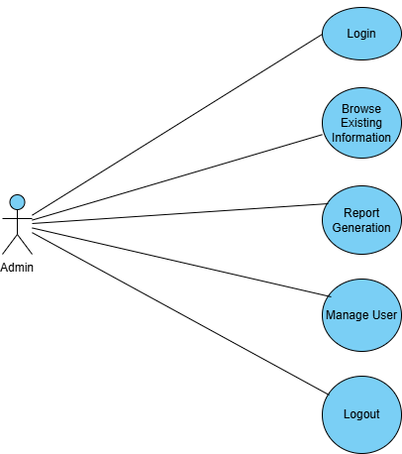
Fig. Use case diagram for admin

- In Admin use case diagram Admin is the Actor.
- Admin can handle following use cases:
- Login
- Report Generation
- Controls account

User:

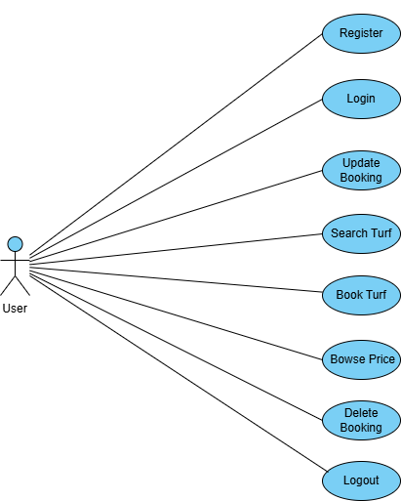

Fig. Use case diagram for User

- In User use case diagram User is the Actor.
- User can handle following use cases:
- Register
- Login
- Search Turf
- Browse Turf Photos
- Browse Turf Price
- Book Turf
- Delete Booking

Turf Owner:

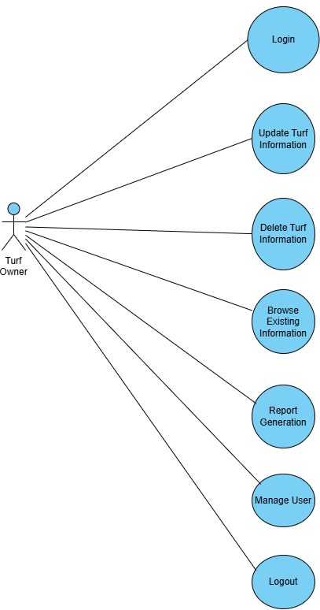
Fig. Use case diagram for Turf Owner

- In Turf Owner use case diagram Turf Owner is the Actor.
- Turf Owner can handle following use cases:
- Register
- Login
- Search Turf Details
- Update Turf Details
- Delete Turf Details
- Payback Details

